**DEVELOPMENT CONFIGURATION REPORT**

Group C1.04.05

12/02/2023

Author(s):

Carlos Bermejo Soria,[*carbersor@alum.us.es*](mailto:carbersor@alum.us.es)

Daniel Gallardo Martos,[*dangalmar@alum.us.es*](mailto:dangalmar@alum.us.es)

Pedro González Marcos, [*pedgonmar2@alum.us.es*](mailto:pedgonmar2@alum.us.es)

Fernando José Mateos Gómez, [*fermatgom@alum.us.es*](mailto:fermatgom@alum.us.es)

Carlos Zarzuela Reina, [*carzarrei@alum.us.es*](mailto:carzarrei@alum.us.es)

# **Table of contents**

**Table of contents** **2**

**1. Executive summary** **3**

**2. Revision table** **3**

**3. Introduction** **3**

**4. Contents** **3,4,5**

4.1. Tools and Platforms: 3

4.2. Environment Configuration 4

4.4. Environment deployment 4

4.3. Images showing the project working 4,5

**5. Conclusions** **5**

**6. Bibliography** **6**

# **Executive summary**

This report provides an overview of the software development configuration process currently in use at our organization. The goal of this report is to inform about the tools and platforms that we are using and the environment configuration in order to better understand how we work and make it easier for future developers to continue the project.

# **Revision table**

| **No** | **Date** | **Description** |
| --- | --- | --- |
| 1.0 | 14/02/2023 | Initial draft of the document |
| 1.1 | 16/02/2023 | First review of the document |

# **Introduction**

Development configuration is an essential part of any software project, as it determines how the code is built, tested, and deployed. It involves setting up the development environment, configuring tools and libraries, and defining the workflow for collaboration among developers. A well-designed development configuration can improve productivity, reduce errors, and ensure consistency in code quality. On the other hand, a poorly configured environment can lead to delays, bugs, and conflicts that hinder the development process. Next we will show how our development configuration is.

# **Contents**

## 

## **4.1. Tools and Platforms**

* Operating System: The development environment was set up on Windows 10.
* Integrated Development Environment (IDE): The project was developed using Eclipse.
* Programming Language: The project was coded in Java 1.8.
* Version Control System: The project uses Git for version control and is hosted on GitHub.
* Other Tools: The project also uses the following tools for development and testing:
  + JUnit for unit testing
  + Acme Framework for web development
  + MariaDB and DBearer for database management

## 

## 

## 

## **4.2. Environment Configuration**

* Package Manager: The project uses Maven to manage dependencies.
* Dependencies:
  + Acme Framework
  + MariaDB
  + Junit

## 4.3. Environment Deploy

In this section we will explain briefly how we should proceed to deploy our environment.

In the first place, we will need the latest version available of the framework ACME, and after that we will only need to create, using the scripts available, a database with the same name as the project created on Eclipse.

With this idea made, we would only need to execute the *create-launcher* script, with the argument being the same as the name of the project, this will create the scripts we will use for running and populating.

**4.4. Images showing the project working**

Database created with MariaDB and DBearer

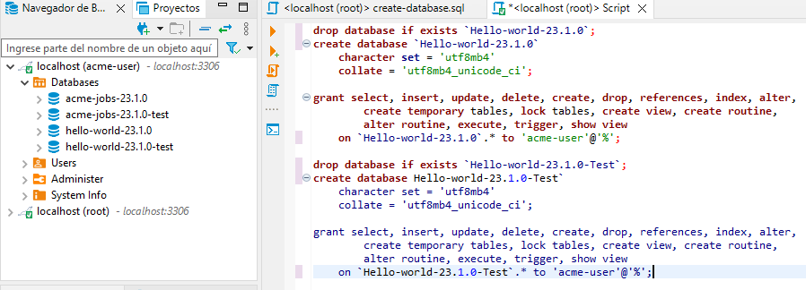

Project and Framework imported

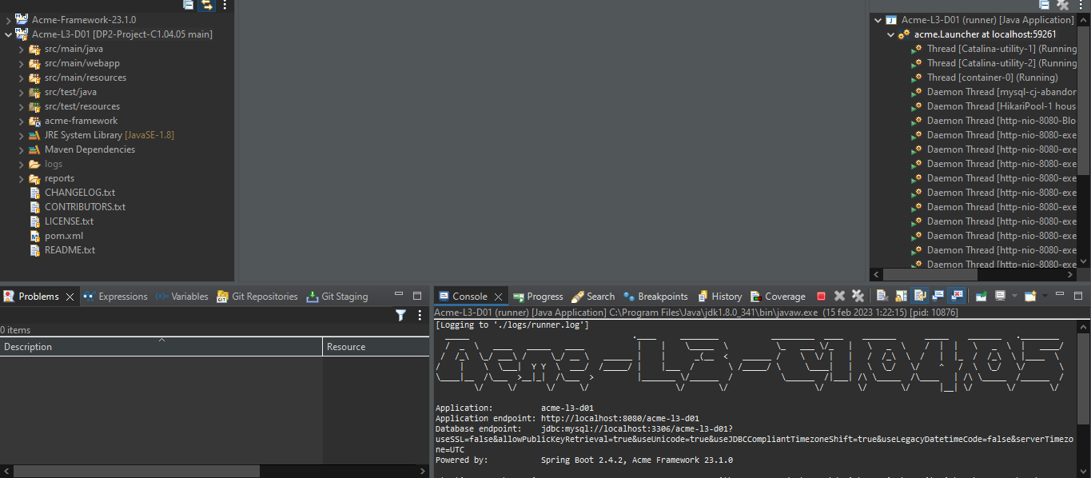

Project in operation

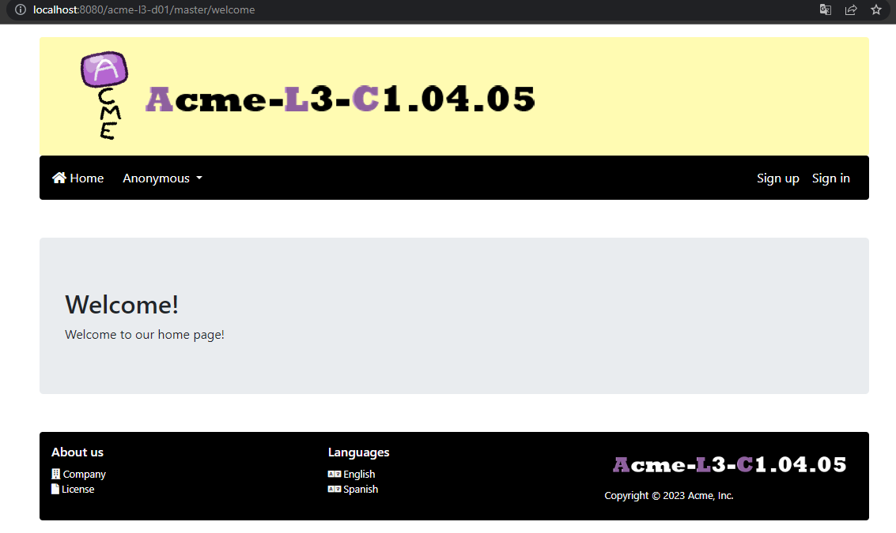

# **Conclusions**

This report provides a comprehensive overview of the development configuration of the software project. The tools, platforms, and environment used for the development process are clearly outlined, making it easier for future developers to continue the project. By having a well-documented development configuration, the project is more maintainable and easier to understand, leading to improved collaboration and faster development times.

# **Bibliography**

<Intentionally blank>